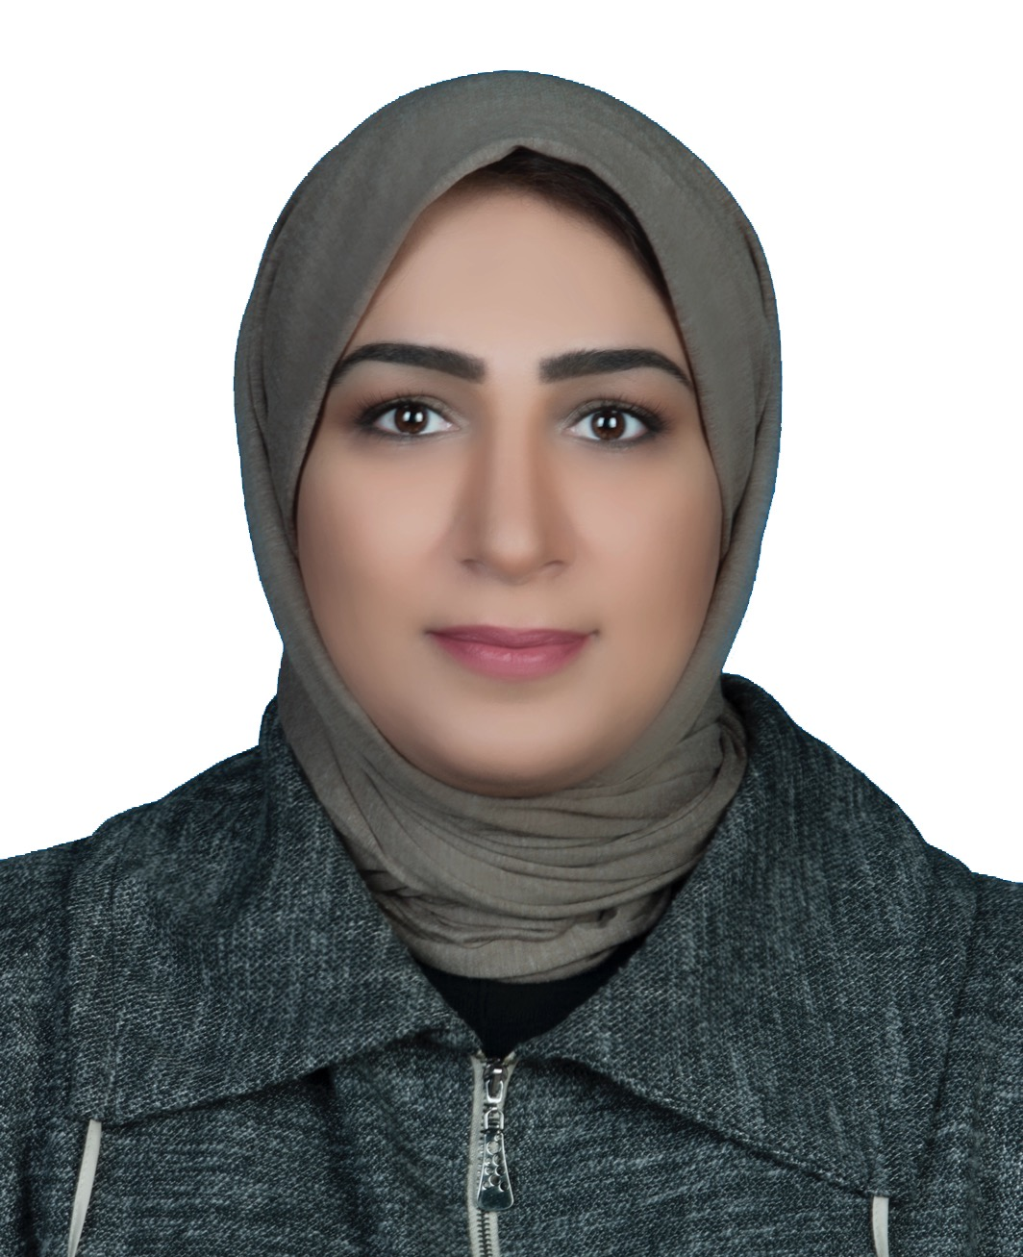 | Name:  Contacts:  Email:  Address: | Eman Mahdi AlMousawi  Mobile: +965 90099974  webmaster@emanalmousawi.com  info@emarkconsult.com  Arraya Center, Floor 28, Office 11, Sharq, Kuwait

Career Profile
An Entrepreneur, a professional entrepreneurship and SME development consultant, author, Kauffman New Venture and Growth Venture FastTrack® Facilitator, Professional Co-Active® Coach, Business Model You® Practitioner, UNIDO Trainer (TOT) and Regular speaker in areas of entrepreneurship and new business venture, business model generation, Lean startup, Cognitive Behavioral (CBT) development for entrepreneurs, social capital & networking, social entrepreneurship, women entrepreneurship, entrepreneurial design thinking and small businesses development.
An adaptable, conscientious, enthusiastic, and self-motivated entrepreneur with exposure to a wide range of areas, possessing excellent planning, analysis, and communication skills combined with the ability to relate well to people at all levels.
Eman has contributed to various projects, workshops, conferences to improve the standing of entrepreneurship development in Kuwait and the GCC region. I have participated in strategic planning sessions for Kuwait National Fund for Small and Medium Enterprises Development, worked with The World Bank for mapping entrepreneurship ecosystem in Kuwait, and participated as a consultant in enhancing business environment committee in Kuwaiti Parliament.

Education
Qualifications | Institution | Country | Year
DBA (Preparing)  An Assessment of the impact of social capital, personal passion and attitude toward entrepreneurial behavioral intention to start a successful business. The case of potential entrepreneurs in Kuwait. | Maastricht School of Management (MSM) | Netherland
MBA (Distinction) | Kuwait Maastricht Business School (KMBS) | Kuwait | 2009
BSC in Computer Science, Minor Organization and Personnel | Kuwait University | Kuwait | 1998

Published Research Paper
- “Intention to purchase fake products in an Islamic country” published in 2011, in the journal of Education, Business and Society: Contemporary Middle Eastern Issues Vol 5 (1): 6-22.

Professional Experience and Responsibilities
- July 2003 – up to date: Founder, and CEO of EMARK General Trading & Contracting CO.
I had focal role in identify & evaluating business opportunities for EMARK, carrying out the function of strategic planning, budgeting, directing the investment, and developing.
- 2010 – up to date: Partner & Managing Director “EMARK Consulting & Training"
- Coaching for business model innovation and value proposition design in corporate teams.
- Coaching business startups and entrepreneurs.
- Consulting function related to identifying the human capital needs and rehabilitation and restructuring of government sector manpower and workforce.
- Designing and Conducting Entrepreneurship training programs to address and brainstorm focal new business issues:
- What business should I start, idea creation and validation (workshop).
- Start your own business (training course)
- Develop your small business (training course)
- Make your business run without you (training course)
- Write your business plan (workshop)
- Self-made entrepreneurs (lecture)
- Business Coaching & Mentoring (Training Course)
- Business Model Generation (Workshop)
- How to teach entrepreneurship (Training course for entrepreneurship educators)
- How to coach entrepreneurs (Workshops for entrepreneurship coaches and mentors)
- I had prime role in leading tasks such as writing strategies, monitor implementation and suggest employees training plan.
- Providing evaluated investment opportunities in GCC countries, validating feasibility studies, preparing business plans and undertaking fund raising exercise (both equity and debt) using our worldwide network including multinational organization, financial institutions and high network individuals.
- I act as the leading expert for Knight International-UK for iMA Practitioners Program through EMARK.

Work Experience in SME’s Strategic Planning
- I conducted a full study for SME’s Ecosystem in Bahrain in 2013 and investigated Tamkeen, BDB, Ebdaa Bank and UNIDO, for financial and nonfinancial services for starting new businesses.
- I was responsible for Developing Economic Program for SME’s in Kuwait include mapping the ecosystem, strategic and action plans, advocacy programs, one stop shop, Pre-Incubation Program.

Work Experience in Entrepreneurship & Counseling
- As Managing Director of EMARK signed a partnership agreement with Kauffman Foundation, to become their Sole Partner in the State of Kuwait.
- I conducted recently business counseling for many startup business clients, identifying investment promotion opportunities, and network worldwide in United Nations Industrial Development Organization (UNIDO) Bahrain in 2014.
- Designing programs for stimulating the spirit of entrepreneurship among Kuwaiti Youth.
- I participated as a mentor in Mix N Mentor event in Kuwait.

- 2004 – up to date: Founder & Partner, CHARISMA Institute
Founding, Planning, Overlooking HR & Marketing, Building Business Automation Model

- 2003 – 2008: System Analyst, Kuwait University, Shuwaikh, Kuwait
System analysis, organization restructuring & developing.
- 1998 – 2003: Programmer & Designs Planner, Kuwait University, Shuwaikh, Kuwait
Admissions program, Admissions and Registration Dean Strategic Plan, Graduation Program System.

Qualification
- Certified Kauffman FastTrac® Facilitator for New Venture Program
- Certified Kauffman FastTrac® Facilitator Growth Venture Program
- CTI Co-Active® Professional Coach
- Business Model You® Certified Practitioner
- Certified Trainer (TOT)

Professional Memberships
- Kuwait Economic Society, Kuwait.
- Kuwait Red Crescent Society, Kuwait.
- Strategic Management Society (SMS), Chicago, USA.
- Project Management Institute (PMI), PA, USA.
- United States Association for Small Business and Entrepreneurship (USASBE), Boston, USA.

Conferences and professional participations
- Discover Entrepreneurship Program, Wave 28, World Bank with Kuwait National Fund, June 2017.
- Entrepreneurial Experiments and New Temporary Markets, Kuwait Municipality, May 2017.
- Mix N Mentor as a mentor, Kuwait National Fund for small and medium business development, by Wamda, 10 May 2017.
- Opportunity Café Entrepreneurial Program, initiative by Amideast and Starbuck, April 2017.
- Developing and Reviewing the National Fund Law, and The Industrial Bank Law, Kuwait Parliament, February 2017.
- Business Plan Generation for Startups in Food Sector, Kuwait, Feb 2017.
- Business Model Development, Leaders Group (High level leaders), Kingdom of Bahrain, 6 Aug 2016.
- Branding for Startups, Manpower & Government Restructuring Program (MGRP), Kuwait,
27 April 2016.
- Branding for Entrepreneurs, Manpower & Government Restructuring Program (MGRP), Kuwait,
1 March 2016.
- Pricing for Small Businesses, Manpower & Government Restructuring Program (MGRP), Kuwait, 26 January 2016.
- My Entrepreneurial Success Story, QARAR Conference, JW Marriott, Kuwait, 30 August 2015
- Management and CBT, Bahrain Petroleum Company (BAPCO), 28-29 March 2015.
- Management Skills for New Business Owners, Kuwait Business Women Network,15 March 2015.
- Planning Skills for Teachers, Ministry of Education, Kuwait, 4 March 2015.
- Managing Stress Using CBT Workshop, Stress Management for Better Employee Performance Annual Conference, Bahrain,28 January 2015.
- Management & Leadership Skills, Entrepreneurship Development and Investment Promotion Program (EDIP), United Nations Industrial Development Organization (UNIDO), Bahrain, 16 December 2014.
- Innovation in Product & Services Development for SME’s, Mubader Program, Kuwait University, Kuwait, 20 Feb 2014.
- My Entrepreneurial Experience, National Forum for Small Business, Al-BABTAIN Library, Kuwait, 3Feb 2014.
- Management Skills, Intrapreneurship, Ministry of Education, Schools, Jan & Feb 2014.
- Entrepreneurs Communication Skills Using iMA, Business Symposium 7, University of Bahrain, Bahrain, Nov 2013.
- Address the challenges of Kuwaiti women Entrepreneurs, Gulf Women's and leadership Conference, Bahrain, Mar 2013.
- Inspirational Speech for Entrepreneurs, Kuwait Small Projects Development Company, Kuwait

Research & Studies
- An Assessment of The Impact of Social Capital, Personal Passion and Attitude Towards Entrepreneurial Behavioral Intentions, The case of potential entrepreneurs in Kuwait (Doctorate Research in progress)
- An Investigation of The Behavioral Intention of Purchasing Non-Deceptive Counterfeit Products in Kuwait (Master Thesis)
- Managing Innovation Strategy in Quality Net Using Dual Tool Method of Star Model & Innovative Balanced Score Card (iBSC).
- Women Entrepreneurs, Work-Family Balance.
- Case Study for HARPO Strategic Plan.
- Quality Function Deployment (QFD) for Health Care Institute.
- Moving Health Care Institute Performance to a Higher Level Using Lean Six Sigma Strategy.
- Challenges facing Kuwaiti Women Entrepreneurs.
- Communication skills using iMA Language for managers.
- Cognitive factors influencing entrepreneur’s behavior.
- Using CBD for building entrepreneurial mindset for GCC citizen.

Skills
- Regular Speaker & Lecturer in Entrepreneurship, Lean Startup, New Business Venture & Business Growth
- Entrepreneurship Educator
- Kauffman Foundation Facilitator for the FastTrac® New Venture.
- Kauffman Foundation Facilitator for the FastTrac® Growth Venture.
- CTI Co-Active® Coach
- UNIDO Trainer.
- iMA Practitioner.
- Coaching and Mentoring for Small and Medium Businesses.
- Motivational Speaker in Social Entrepreneurship

Expert Training programs attended:
I attended training courses in different areas including entrepreneurship, business planning & management, leadership, and business counseling. A list of these courses follows:
- Professional Certified Trainer (PCT®) Practitioner, World Trainers Club, Kuwait, Aug 2017.
- TOT Program for Discovering Entrepreneurship, World Bank, for Kuwait National Fund, Kuwait, Feb 2017.
- The Entrepreneur’s Boot Camp: A Deep Dive for New Ventures, Babson University, Boston, Jan2017
- Price-BABSON Symposium for Entrepreneurship Educators-SEE 39, Babson University, Boston, Jan2017
- Business Model Canvas Generation Master Class, London, May 2016
- Business Model You® Certified Practitioner Course by Dr. Timothy Clark, Munich, March 2016
- Certified Kauffman FastTrac® Facilitator for New Venture Program, June 2015
- Certified Kauffman FastTrac® Facilitator Growth Program, June 2015
- CTI’s Synergy Co-Active Coaching, CTI, Dubai, October 2015
- CTI’s Process Co-Active Coaching, CTI, Dubai, September 2015
- CTI’s Balance Co-Active Coaching, CTI, Dubai, June 2015
- CTI’s Fulfillment Co-Active Coaching, CTI, Dubai, May 2015
- CTI’s Fundamental Co-Active Coaching, CTI, Dubai, Apr 2015
- Certified Consultant Program CCP, Ebdaa Center, Dubai, UAE March 2015.
- Cognitive Behavior Counseling Program, Beck Institute, Philadelphia, USA November 2014
- Leading Your Small Business Through Its Life Cycle, Harvard Business School, Boston, USA June 2014.
- Entrepreneurship Development and Investment Promotion Program, United Nations Industrial Development Organization (UNIDO), Bahrain Aug/Sep 2014.
- Train of Trainers Program on Enterprise Creation, United Nations Industrial Development Organization (UNIDO) & Jordan Enterprise Development Corporation (JEDCO), Jordan Aug 2014.
- Leadership Success Summit, Robin Sharma & Verni Harnish, Bahrain, February 2014.
- Promoting Women’s Entrepreneurship & Developing Economic Program, Arab Women Leadership Institute, Kuwait, December 2013.
- Cognitive Behavioral Counseling Program, Edrac Institute, Prof. Rashid Al-Sahel, Kuwait June – August 2013.
- Methods of Preparing Market Studies for Small Businesses, KES, Kuwait, December 2010.
- Tom McCarthy’s 10 Challenges for Outstanding Leaders, Kuwait, March, 2007.
- Personnel Management Course, Kuwait, May, 2006.
- Leadership Skills for Women, British Embassy, Kuwait, April 2006.
- Project Management Professional (PMP), Kuwait Society of Engineers, Kuwait, July 2005.
- Planning and Projects Management, February 2005.
- MS Projects, Kuwait, January 2005.
- Modeling Business Requirements to Create a Database, Kuwait December 2004.
- Business Process Mapping, Kuwait, December 2004.
- Negotiation & Contracting, Kuwait, May 2002.
- Scenario Planning, Kuwait, March 2002.
- Strategic Planning, Kuwait, March 2001.

References
Can be applied upon request.

