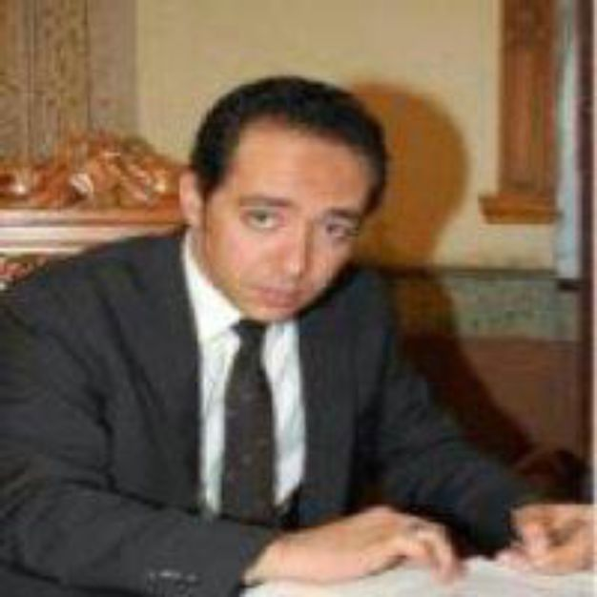

Ahmed El-Saba
I have more than 18 years of experience in finance, investment, and strategy management. My experience in field of Financial Markets, Asset Management, Private Equity, and Risk Management. My area of interest includes investment analysis and portfolio management, financial analysis and modeling, capital budgeting, valuation techniques, risk analysis and modeling, merger and acquisition, IFRS, cash management and treasury, econometrics analysis, and operations research & statistics. I am PhD in finance researcher, MBA in finance, and BBA. I am a member of American Finance Association., Currently I am President and managing director at Wise Investment and Profile Industrial Development, Owner at Wise financial advisors, and CIO & board Summary member at Arabica International Trade.
Experience Dec 2005 - Present Wise Financial Advisors Cairo, Egypt
Financial Adviser, Owner
- Feasibility studies, and capital structure decisions.
- Profitability planning, and cash flow planning.
- Comprehensive financial plan and budgeting.
- Valuation.
Wise Investment and
Dec 2011- Present Industrial Development Cairo, Egypt
President & Managing Director
- Asset Allocation.
- Setting corporate strategy.
- Potential merger and acquisitions.
Nov 2014- Present Arabica International Trade Cairo, Egypt
CIO, Board Member
- Investment decisions.
- Setting financial strategy.
Themar Securities (Listed in
July 2015- Present Egyptian Stock Market) Cairo, Egypt
Audit and Risk Committee Member
- Reviewing the Company’s annual financial statements.
- Reviewing the external auditors’ proposed scope of audit and approach, including coordination of audit efforts with internal audit.
Jeddah,
Jan - July 2012 Al-Nefaie Investment Group Saudi Arabia Investment Adviser
- Restructuring asset management division.
- Building investment modules.
- Setting asset allocation for equity portfolios.
Jan-2004 - Dec 2008 Brent Group Holding Cairo, Egypt Investment & Financial Adviser
- Measure financial performance (KPIs), and reporting to CEO.
- Analysis and valuation new venture.
- Profitability and cash planning.
Sep 2000- Oct 2003 S.I.B-Finance Cairo. Egypt
Senior Financial Analyst and Chartist.
- Calculating expected returns and its risk for securities and portfolios.
- Identifying undervalue and overvalue securities.
- Financial analysis, and spreadsheets.
May 1998- Aug 2000 Agyad Securities Cairo, Egypt
Financial Analyst
- Calculate Beta for each security.
- Financial analysis and modeling.
- Equity valuation.
May 1998- Now Freelance Investment and Wealth Advisor Egypt, Saudi Arabia, United Arab Emirates, and Qatar
- Asset Allocation and Portfolio Management.
- Financial analysis and modeling.
- Equity valuation.
- Financial Restructuring and analysis of M&A.
- Risk Control and Management.
- Feasibility Studies for new Projects.
Training Experiences
May 2002- Present Freelance Trainer in Finance Cairo, Egypt Key Programs and Workshops
- Advanced Investment Management 2004, presented to Kuwait Fund for Arab Economic Development, through Gasco Group.
- Finance and Investment 2004-2005, Arab Administrative Development Organization (stemming from the League of Arab States).
- Advanced Cash and Treasury Management 2013, presented to Obekan Investment Group, Through Ecoman Consultancy.
- Budgeting and Forecasting Techniques 2014, presented to Qatar Gas, through Masters Consultancy and Training.
Academic Experiences
2002 - Present Freelance Instructor & Lecturer Cairo, Egypt
- Misr University for Science and Technology - MUST
- Thebes academy
- Benha University
Courses include
- Financial Markets and treasury management.
- Quantitative finance and Investment analysis.
- Banking management, control, and risk management.
- Financial analysis, forecasting and modeling.
- Valuation and budgeting.

Education
- PhD in Finance, Benha University- Expected January 2017.
Entitle " Modeling and Forecasting Egyptian Stock Market Volatility Using GARCH Models "
Include:
- Cross Section Analysis of Stock Returns -Asset Pricing Models
- Volatility Forecasting
- MBA in Finance, Benha University, 2006.
Entitle " Portfolio Rational Decisions for Egyptian Investor “
Include:
- Securities Analysis and Selection - Investment Analysis
- Asset Allocation Strategies - Capital Asset Pricing Model
- Portfolio Selection Technique - Diversification Strategies
- Courses in Mathematical Statistics and Operations Research, ISSR, Cairo University, 2001.
- Courses in Financial Econometrics, time series, and statistics, ISSR, Cairo

University, 2012.
BBA, Business Administration, Cairo University,1998.
- Financial forecasting, and modeling.
- Valuation techniques, Investment appraisal and capital budgeting.
- Cash and treasury management.
- Investment analysis and portfolio management.
- Derivatives, volatility modeling and risk management.
- Financial Restructuring, and Merger & acquisition.
- IFRS
Interest
Research and Publications
Skills
Professional
Membership
Personal Info
Contact
- Compliance, and anti-money laundering- AML
- More than ten working paper published in academic conferences and economic forum. Five textbook in press; covered area of finance, and investment.
- MS Office 2013
- SPSS
- Eviews 8
- MetaStock Pro
- WINQSB
- FinPortfolio
- XLSTAT
- Risk Simulator
Member of American Finance Association Affiliate of Market Technicians Association
Married with two children Exempt from Military Service Born in 18 of May 1976
asaba@link.net
+201001304647
October, 2016

