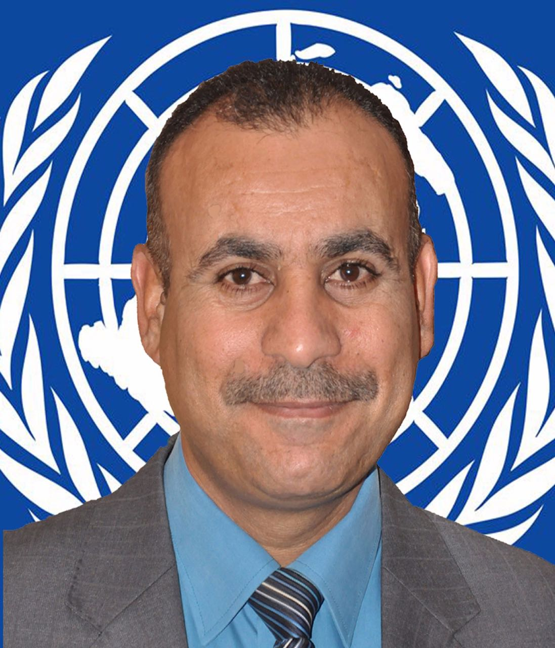

C.V.

Career Objective
Seeking a challenging opportunity with a creative, motivated and professional environment, where sharing with others is essential to gain more knowledge and experience, and where my academic background, practical experience can be applied. I am ready to Work or train in a challenging environment in a business company or training where I can utilize my capabilities to advance in my career and to gets the work in your company under the policies and regulations of the company and effective cooperation with staff and Looking for both personal and professional growth makes me capable of working confidently under pressure.

Personal Information:
Name: Dheyaa Naser Hussein | Senior Project Assistant
Citizenship: Iraqi | ID: Iraq
Occupation: SMEs. Trainer & Business consultant | Date of Birth: (1-1-1970): Babylon
Current Address: AL-binaa AL- jahiz Q. p.o.box :177 | City: Karbala
Province: Karbala | Country: Iraq
Mobile Phone:009647904414647 | Telephone:009647706076400
E-mail:dheyaa8@gmail.com | d.heyaa@hotmail.com
Practical skills: M.S.Word, Excel, Power Point, Internet Applications. | Skype : dheyaa.hussein
Languages | Arabic (Mother language), English (.good; speaking, writing and reading).

Educational:
Dates | University / College | Degree
18 January to 8 march /2012 | Sun university Australia | Diploma in Crisis Management & Strategic Planning
2005 | Baghdad university / college of political science | B.Sc. in political science
2002 | Karbala University / College of Administration and Economy | B.Sc. in Business Administration
10/9-20/11/2004 | The American University of Science and Technology A.U.T. Lebanon | certificate 240 hour training program in computer skills , leadership And governance

Work Experience:
With a 10 -year service record as Trainer, project manager. Director of voter educations project in Karbala with DAI in 2008-2010, Senior Project Management Consultant, as well as project management consultant and SMEs. Trainer with public and private sector organizations in Iraq, covering Construction, government sectors and companies in Iraq.
Certified trainer for the Iraqi youth initiative "how to start your business" dedicated work to helped young Iraqis entrepreneurs to develop sustainable business plans and prepare to receive youth-friendly loans.
Currently a freelancer senior management consultant, providing consulting and training with leading consulting and training an accredited ILO " Start your Business " and "Simplified Start And Improve Your Business "Trainer and I authorized to train Entrepreneurs and provide follow up support interventions according to the requirements and specifications of the programs.
. In 2012 was awarded the Excellence Significant Trainer for finance activity in the "Business Startup for Youth" course of the Iraqi Youth Initiative. USAID-TIJARA-IRAQ.
In 20014 was the Third Goodwill and Diplomatic Relations Advisor - Peace Mission & Diplomatic Relations organization –affiliated to ICHAPS. Until now my position Small Business Development Adviser/Senior Project Assistant in IOM-Iraq.

Professional experience
Dates | Position |  |  | Organization
20/8/2015 | Small Business Development Adviser/Senior Project Assistant |  |  | IOM-Iraq Mission- Community Stabilization and Revitalization
1/4/2014 part time | Business Coach and field Mentor |  |  | Relief International (RI) -Advancing Widows’ Assistance via Enterprise (AWAVE) Program-
January 23 - 29 ,2015 | TOT for 11 trainers (6 female ,5 male) Entrepreneurship and small business management course |  |  | Duhok District supported by France embassy in Iraq Kurdistan region.
1/1/-31/3/2015 | Market Development Assistant Consultant |  |  | Family Health International - FHI360- Iraq Opportunities Project (USAID/Foras)
1/4/2013-31/12/2014 | Business development specialist –  Iraq Opportunities Project (USAID/Foras) |  |  | International Medical Corps –IMC-Iraq
1/10-31/12/2014 part time | Business Coach and field Mentor |  |  | Relief International (RI) -Women Leveraging the Internet for Financial Transformation” (WLIFT) Program,
2014 part time | Trainer (empowering vulnerable Iraqis through entrepreneurship program |  |  | Relief International - Iraq Opportunities Project (USAID/Foras)
20/3/2010-1/4/2013 | Entrepreneurs consultant & SMEs trainer |  |  | USAID-Tijara/ Economic Provincial Growth Program / Iraqi Youth Initiative Program ( IYI )Karbala business development t center
01/10/2009-19/3/2010 | Entrepreneurs consultant & SMEs trainer |  |  | USAID-Tijara/KarbalaPRT, Economic Provincial Growth Program / Karbala Business Development Center (KBDC)
2011- part time | Trainer – start your business SIYB |  |  | ILO-Iraq
15-30/2/2010 | Project manager of voter education |  |  | DAI
1-30/1/2009 | Project manager of voter education |  |  | DAI
2007-2010 | Head of art & cultural dep. |  |  | Alwehda youth forum –Karbala
20/8/2007-2009 | Head of computers and information department |  |  | Karbala's Directorate of Youth and Sport
-2007 | Public Relations Division dep. |  |  | Karbala's Directorate of Youth and Sport
2006 | Trainer start your business |  |  | Business Innovation Programs- BIP-Iraq
1/8/2003-1/10/2005 | Division responsible financial and Administrative |  |  | Karbala's Directorate of Youth and Sport
20/10/2002-1/8/2003 | Administration Observer |  |  | Karbala Youth Forum / Ministry of Youth and Sports
1999-2001 | structured data |  |  | Central Information Office / Ministry of the Interior
Certifications,

Dates | School or Institution |  |  | Certificate or program
3.10.2006 | House Foundation work for the development of Norwegian trade BIP |  |  | TOT in how to start your business
25.3.2011 | Iraqi youth initiative-USAID-TIJARA-Iraq |  |  | Trainer how to start your business
16.3.2011 | ILO |  |  | accredited Currently a freelancer senior management consultant Start your Business " and "Simplified Start And Improve Your Business
1.5.2015 | Canada Global Consulting and Training Centre®  Ltd. (CGC®) |  |  | Professional Certified Trainer  ™ (PCT™)
Training And Seminars:
Dates | School or Institution |  | Certificate or program
3-5/12/2016 | Arab center for research &policy studies -Doha institute for graduate studies |  | Participant in third annual gulf studies forum
19-Oct-2016 Sulimani | Smart Web |  | E-Business& E-Marketing
23-26. Jul.2016 Erbil | Franklin covey middle east |  | Leadership/ Training, The 7 Habits of Highly Effective People Signature program.
20/8-20/9/2015 | IOM-Iraq Mission- Community Stabilization and Revitalization CEFE |  | Small Business Development Adviser and Certified Trainer
25-30.10.2014 Lebanon | Beyond IRD and RI |  | HR management training course
April 24-30,2014 Erbil - Iraq | Relief International - Iraq Opportunities Project (USAID/Foras) |  | TOT ((empowering vulnerable Iraqis through entrepreneurship program)
Doha, Qatar  From 6-8 March, 2014 | Georgetown University School of Foreign Service in Qatar (GU-Q) |  | Doha Evidence Symposium Arab Youth Employment:  “What Works” To Improve Youth Labour Productivity?
Nov. 2nd – 4th, 2013 Erbil best inn hotel | Program Sustainable Economic Development in Iraq (SEDI)-GIZ -BMZ |  | Iraqi Young Leaders Academy
Rotana Hotel Erbil on 20 – 21 November 2012 | SANAD-GIZ-BMZ-IRAQ |  | Promoting SME Finance in Iraq – How to Increase Scale and Efficiency
Nov. 18-19.2012 | USAID-TIJARA-IRAQ |  | Private sector job creation workshop-SBDC partnerships
October. 16-17.2012- Rotana Hotel Erbil | GIZ-BMZ-Iraq |  | Public privet development dialogue conference
30. Sep. – 1. October. 2012 | USAID-TIJARA- Iraq |  | Media relations for SBDC programs training course
14-18/7/2012 | Dubai-giftedness2012 |  | Attendees -the 12th edition of the Asia Pacific Conference on Giftedness in the United Arab Emirates from July 14th to July 18th 2012 at the Dubai International Convention & Exhibition Center.
1-8/5/2012 | Cyprus –change for leadership Co. |  | Strategic leadership training course
7-10/may/2012 | ILO& UNOPS- private sector development programme (PSDP) |  | Participant in the SIYB institutional workshop
12/11/2011 | Baghdad |  | TEDx Baghdad conference 2011
8-13 October 2011 | Erbil. Iraq- ILO-UNOPS |  | Refresher TOT workshop for (SYB)&(SSIYB)
20/6-2/7/2011 | ITC-ILO- Turin –Italy |  | Summer academy for sustainable enterprise development - More and better jobs
5-16/3/2011-Erbil | ILO & UNOPS |  | TOT in how to start & improve your business (SIYB)
20/10/2010-Najaf | Proposal Writing Training |  | Negotiation & strategic sciences organization
Damascus, Syria from June 1st – 3rd 2010 | Microfinance network of Arab countries |  | Sanabel The Microfinance Network of Arab Countries  Seventh Annual Conference  http://www.sanabelconf.org/ParticipantsListPdf/ParticipantList-Arabic.pdf
25/3-11/4/2010 - Erbil | USAID-TIJARA |  | TOT in how to start your business
14-16/3/2009-arbil | National Democratic Institute for International NDI / Iraq - Erbil |  | Training of trainers session -T.O.T. program
7/11/2008 | Forum of federations Canada Ottawa |  | Participant in the 4th International Conference on Federalism Young Professionals Program in New Delhi from November 5 to 7, 2007, being hosted in partnership with the Forum of Federations, Ottawa. Issued in Delhi 8th November 2007
04/03/2007 | Babel Center for Human Rights in cooperation with the United Nations |  | TOT
1-30/10/2006-karbala | House Foundation work for the development of Norwegian trade BIP |  | Certificate of training in international youth projects
12/10/2006 | Babel Society for Human Rights |  | Certificate Trainers human rights in the Middle Euphrates
Awards
Significant Trainer for the "Business Startup for Youth" course of the Iraqi Youth Initiative.
USAID-TIJARA-IRAQ
Iraqi Youth Initiative - microfinance, entrepreneurs, apprentices.
31/5/2012-Baghdad
Skills & Activities;
- Leadership skills.
- Finance Trainer
- How to start your business Trainer
- Business Coach and field Mentor
- Market consultant
- Presentation and communications skills.
- An active social person, volunteered in many activities.
- Organizing conferences, business forum, training courses programs and workshops.
- Teaching and training Ability.
- Business development.
- Evaluating Impact of Development Training and Capacity Building
- References:
Name |  | Position |  |  | Contact information
Raymond S. Mendenilla |  | Regional Manager - Midwest,  C2 Education |  |  | Email: mendenilla@email.com  Worldwide Cell: +1-202-621-0043  Skype: raymond.mendenilla  Follow us on Twitter: @YouthIraq  Like us on Facebok: GoYouthIraq  Follow him on Twitter: @RayMendenilla
Susanne E. Jalbert, Ph.D. |  | CEO at Jalbert Consulting |  |  | P.O. Box 112, Winter Park, CO 80482 USA  Tel: +1 970 726 9440  Skype: sejalbert  E-mail: sejalbert@aol.com
Rania bikhazi |  | Enterprise development specialist  ILO regional office for Arab stats |  |  | bikhazi@ilo.org  tel: +961-1-752400  International Labour Organization – Arab stats  Beirut , Lebanon
ben peters |  | Director of Foras program -international medical corps -Iraq |  |  | bpeters@internationalmedicalcorps.org  d.ben.peters@gmail.com  Skype ID - d.ben.peters
Dr. Mohamed Mahmoud El-Gamsy |  | ICHAPS General Secretary of International Council of Human Rights. Arbitration, Politics & Strategic Studies – ICHAPS- Pease mission & diplomatic Relations organization |  |  | politics@ichaps.org  www. ichaps.org
Daniel butler |  | Senior Industry Adviser  Iraq Opportunities Project (USAID/Foras) |  |  | daniel.butler.prtb@gmail.com  +353 86 1733203
Fellowships Membership in organizations
Organization |  |  |  |  | Position
International Council of Human Rights. Arbitration, Politics & Strategic Studies - ICHAPS |  |  |  |  | Third Goodwill and Diplomatic Relations Advisor  - Peace Mission & Diplomatic Relations organization –affiliated to ICHAPS
Iraqi businessmen union – Karbala |  |  |  |  | Business consultant

• Note: All Original Certificates to be provided upon request.

