CURRICULUM VITAE
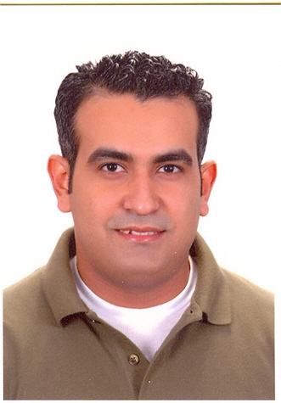
Name: Mohamed Sobhy Ahmed Sayed
Address: Zahraa Nasr city –Nasr city – Cairo – Egypt.
E-mail: m.sobhy@portghalib.com
mo_sobhy81@hotmail.com
Mobile: (+20)1002630258

Personal Data:
- Date of Birth : 28 November 1981
- Nationality : Egyptian.
- Marital Status : Married
- Military Status : unrequired
Education:
- B.sc of commerce.
- Section: accounting.
- Graduation grade: (Pass).
- Place of graduation: Cairo University.
- Year of graduation: May2004
Work Experience:
- Working as a Accountant Manger in MAK HOLDING INVESTMENT Company – EL KHARAFI Group from 2007 till now.
- Worked as an Accountant contracting- Project Port Ghalib Resort with the Emak Contracting Company – EL KHARAFI Group from 2007.
- Worked as an Accountant ( income – payable ) in Hotels Five Stars in SHARM EL SHEIKH Town from 2004 to 2007
- Good User for Accounting programs (ALPHA. Oracle– COMSYS - TM5 Treasury system )
Skills:
 | Languages |  | - English: fluent.  - French: fair.
 | Computer knowledge |  | - Computer software maintenance.  - Windows (XP, millennium, 98)  - Surfing internet.  - Microsoft: excel. Word  - ICDL Course (International Computer Driving License) Which Includes [Windows - Excel - Word - Power Point -IT – Access – Internet.

Best regards"
Mohamed Sobhy

