Currilum vitea

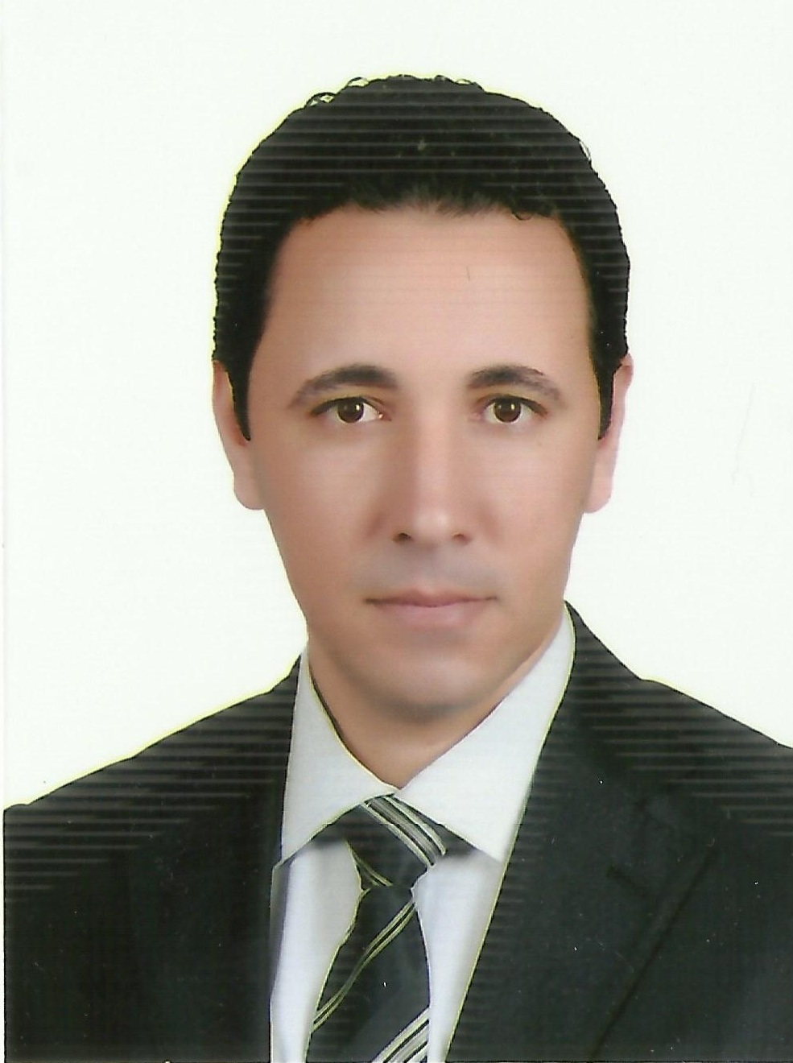

PERSONAI DETAILS
Surname | El-Shafei
Other names | Ahmed Mohammed Diab
Gender | Male
Date of birth | 1/9/1981
Place of birth | Abou-Hammad
Nationality | Egyptian
Marital Status | Married
Passport No. | A03238744 – Issuing office 42
Address | 15 El-Fath El-Islamy St, Mubarak District, Sharkia,  Egypt
Current job | Researcher at Department of Fish Extension, (CLAR).
General specialization | Agricultural Extension and Rural Sociology
Exact specialization | Fish Extension and Socioeconomics
Post. Code: | Abbassa, 44662
Work Phone | (055) 3168658 , (064) 9201621
Work Fax | (055) 3168658 , (055) 3168584
Home Phone | (055) 2264264
Mobile | 01287226147 - 01062158285
Email | Ahmeddiab_clar@yahoo.com  Ahmeddiab55@arc.sci.eg

EMPLOYMENT HISTORY
Employer | Position | Dates  (from-to)
- Agricultural Engineer in (CLAR), Department of Fish Extension. | Central Laboratory for Aquaculture Research, Department of Fish Extension. | 2003 – 2004
- Research Assistant in (CLAR), Department of Fish Extension. | Central Laboratory for Aquaculture Research, Department of Fish Extension. | 2005 - 2009
- Researcher Associate in (CLAR), Department of Fish Extension. | Central Laboratory for Aquaculture Research, Department of Fish Extension. | 2010 – 2015
- Researcher in (CLAR), Department of Fish Extension. | Central Laboratory for Aquaculture Research, Department of Fish Extension. | 2015 – till now

EDUCATION
Degree Obtained | College/ University/ Other | Dates  (from-to)
B. Sc | Faculty of Agriculture, Economic Dept., Rural Sociology and Agricultural Extension Section, Zagazig University, Egypt. | 1998 - 2002
M. Sc | Faculty of Agriculture, Economic, Rural Sociology and Agricultural Extension Dept., Suez Canal University, Egypt.  Title of thesis: A comparative study of fish farmer's extension needs in Sharkia and Ismailia governorates. | 2004 - 2009
P. hD | Faculty of Agriculture, Economic Dept., Agricultural Extension Section, Zagazig University, Egypt.  Title of thesis: Extension requirements for development of some Egyptian lakes. | 2010 - 2015

PUBLICATIONS AND PATENTS
- List of publications:-
- A Study of Some Problems Which Face the Fish Farming in EL-Beheira and EL-Fayoum Governorates, Sahar M.M. El-Basioni, Ahmed M. D. El-Shafei, 2nd Conference of the Egyptian Aquaculture Society, Sept., 2006.
- The Fish Farmers Knowledge Needs Regarding To the Recommendations for Aquaculture in Sharkia and Ismailia Governorates, A.M. El-Sayed, Sahar M.M. El-Basioni, Ahmed M. D. El-Shafei, Agricultural research journal , Suez Canal University, Vol. 9, No. 1, 2008.
- Problems of fishermen in River Nile IN El-Menia Governorat, Sahar M.M. El-Basioni, Ahmed M. D. El-Shafei, Journal of Egyptian Society for Agriculture Extension, Vol. 15, No. 3, 2011.
- Value-chain analysis — An assessment methodology to estimate Egyptian aquaculture sector performance, Graeme Macfadyen, Ahmed Mohamed Nasr Alla, Diaa Al Kenawy, Mohamed Fathi, Hussien Hebicha, Ahmed M. D. El-Shafei, Samy Mohmed Hussein, Ramadan Mohamed Abou-Zeid, Gamal El-Naggar, Aquaculture 362-363 (2012) 18–27.
- Some of variable associated with knowledge of fish farmers to technical recommendations for tilapia over-wintering in Sharkia governorate, Hamed M. H. Semida, Ahmed M. D. El-Shafei, Egy. J. Aqua., Vol.8 No.4 2012.
- Value chain analysis of Egyptian fish seed production, Ahmed M. Nasr-Allah, Malcolm W. Dickson, Diaa A. Al–Kenawy, Mohamed Fathi, Gamal O. El-Naggar, Gamal E. Azazy, Youssif Sh. Grana and Ahmed M. D. El-Shafei, 4th Conference of Central Laboratory for Aquaculture Research (CLAR), Egy. J. Aquac., Abbassa Int. J. Aqua., 353-374, 2014.
- Knowledge Needs for Fishermen in Burllus and Edko Lakes, Ahmed M.D. El-Shafei, I.M.S. Newsar, Sahar M.M. El-Basioni and Hosna M.I. Foda, Zagazig J. Agric. Res., Vol. 41 No. (6) 2014.
- Factors Affecting on Adoption of Fish Farming Enterprises the Innovations Technical Recommendations for Mariculture, Hamed M. H. Semida, Ahmed M. D. El-Shafei and Mohammed A. Attia, Egy. J. Aqua., Vol.6 No.2 2016.

RESEARCH PROJECTS
- Effect of fish production development on standard of living for workers in this activity at Edko, Beheira Governorate, World Fish Center and Central Laboratory for Aquaculture Research, August 2009.
- Exploitation of fish farms ponds in cultivation of wheat crop - Central Laboratory for Aquaculture Research - 2012.
- Improving employment and incomes through development of Egypt’s aquaculture sector (IEIDEAS), has focused on the development of the Egyptian aquaculture value chain, funded by the Swiss Agency for Development and Cooperation and managed by WorldFish and CARE in collaboration with the Ministry of Agriculture and Land Reclamation, Start date 2011, End date 2014.
- Mediterranean Network of sustainable small-scale fishing communities ―FISHINMED, Start date 10/11/2011, End date 09/11/2015.
- Management of water and salinity in the Nile Delta: A cross-scale integrated analysis of efficiency and equity issues, International Center for Agricultural Research in the Dry Areas (ICARDA) Regional Coordinator & International Water National Water Research Center (NWRC) Management Institute (IWMI), and Agricultural Research Center (ARC)., from 2013 to 2015.
- Study on Marriott Lake – Alexandria governorate to improve quality of water, fish and productivity - Central Laboratory for Aquaculture Research in cooperation with the General authority for Fish Resources Development (GAFRD) - from 2014 to 2015.
- Studies on quality of waste agricultural water and its impact on fish production at own farms - Central Laboratory for Aquaculture Research - from 2014 to 2016.
- EU Twinning project EG12/ ENP-AP/AG/19 Support the improvement of agricultural research in Egypt through the modernization of the agricultural research Center, 2016.

TRAINING COURSES

Internal Training
Training attended / Technical skills acquired | Place | Dates  (From-To)
- Common diseases in fish farms. | Central Laboratory for Aquaculture Research | From 10-1-2004  To 21-1-2004
- Basics of hatching and fish farming. | Central Laboratory for Aquaculture Research | From 23-1-2004 To 2-2-2004
- Basics of construction and management for fish farms. | Central Laboratory for Aquaculture Research | From 7-2-2004 To 18-2-2004
- Different types of intensive aquaculture. | Central Laboratory for Aquaculture Research | From 22-2-2004 To 6-3-2004
- See Water Fish Spawning, Rearing and Aquaculture. | Central Laboratory for Aquaculture Research | From 20-3-2004 To 31-3-2004
- Ecology and biology of aquaculture. | Central Laboratory for Aquaculture Research | From 10-4-2004 To 24-4-2004
- Fish Processing and quality control. | Central Laboratory for Aquaculture Research | From 20-11-2004 To 1-12-2004
- Use of internet and information technology in scientific research. | Central Laboratory for Aquaculture Research | From 4-5-2008 To 6-5-2008
- Basics of aquaculture. | Central Laboratory for Aquaculture Research | From 23-11-2008 To 2-12-2008
- Improve quality of fish production in light of international standards | Central Laboratory for Aquaculture Research | From 4-12-2011 To 8-12-2011
- Aquaculture technology | Central Laboratory for Aquaculture Research | From 5-2-2012 To 23-2-2012
- Fish health and welfare | Central Laboratory for Aquaculture Research | From 15-4-2012 To 26-4-2012
- Freshwater fish hatchery | Central Laboratory for Aquaculture Research | From 27-5-2012 To 7-6-2012
- Fish feed technology | Central Laboratory for Aquaculture Research | From 13-1-2013 To 24-1-2013
- Theoretical and practical applications for different scientific devices | Central Laboratory for Aquaculture Research | From 24-2-2013 To 7-3-2013
- Water quality management in fish farms | Central Laboratory for Aquaculture Research | From 16-2-2014 To 27-2-2014
- Fish diseases in fish farms | Central Laboratory for Aquaculture Research | From 5-4-2015 To 9-4- 2015
- Water quality management in fish farms | Central Laboratory for Aquaculture Research | From 7-2-2016 To 18-2- 2016
- Fish health and management | Central Laboratory for Aquaculture Research | From 6-3-2016 To 17-3- 2016
- Freshwater fish hatchery (Tilapia, Carb, and Catfish) | Central Laboratory for Aquaculture Research | From 24-4-2016 To 5-5-2016

External Training
Training attended / Technical skills acquired | Place | Dates  (From-To)
- Management of environmental effect for aquaculture projects. | World Fish Center (ICLARM). | From 14-12-2008 To 18-12-2008
- Mechanism of fish extension and its role at development fish sector | World Fish Center (ICLARM). | From 24-12-2009 To 29-12-2009
- Modern technology for shrimp farming | Arab Organization for Agricultural Development –Cairo university. | From 9-9-2012 To 11-9-2012
- How to Write  Your Scientific Paper | Cairo University Center of Printing and Publishing. | From 10-3-2013 To 14-3-2013
- Fish hatcheries "methods of construction and problems" | Arab Organization for Agricultural development – Egypt. | From 8-9-2013 To 10-9-2013
- The scientific basis for salinity and water quality in aquaculture. | Fish farm and Fish hatchery of Hajj Mohamed Hosni, Kafr El sheikh government. | From 10-11-2013 To 21-11-2013
- Design, implementation scientific research and prepared publication for international journals | Faculty of science, Alexandria University. | From 20-8-2014 To 24-8-2014
- Management of water quality and salinity in aquaculture. | Fish farm and Fish hatchery of Dr. Salah Ibrahim, Kafr El sheikh government. | From 11-4-2015 To 18-4-2015
- Economic evaluation for fish farms at Kafr El sheikh government. | Fish farm Eng. Ahmed El-Sharaki, Kafr El sheikh government. | From 5-4-2015 To 12-4- 2015
- Getting started with your research (Research Skills – Life Skills) | Fish Farming and Technology Institute, Suez Canal University. | From 16-10-2016 To 19-10- 2015

Aborad Training
Training attended / Technical skills acquired | Place | Dates  (From-To)
- Training course for regional desk operators, FISHINMED project. | CIHEAM-BARI, Valenzano (Bari), Italy | From 23-2-2015 To 27-2- 2015
- Training course for Gender and Small Scale Fisheries Entrepreneurship For Fishing Community Development | Japan International Cooperation Agency - JICA, Japan | From 9-2-2017 To 9-4- 2017

PRECEDENT EXPERIENCE
- Work at department of fish extension research and training from 2002 –tell now.
- Supervision on Training courses and Seminars at CLAR.
- Preparation extension bulletins in aquaculture field.
- Preparation economic evaluation for fish farms projects.
- Participation at many training courses in and out central laboratory for aquaculture research.
- Participate at many Feasibility Studies.
- Member in organizing committee for scientific conferences:
- Modern Attitudes in Aquaculture.
- The Sustainable Development of Aquaculture.
- The eighth international symposium on tilapia (ISTA).
- Aquaculture between science and application.
- The Sustainable Development of Aquaculture.
- Member at technical office for CLAR Director.
- Vocal Point of Central Laboratory for Aquaculture Research in Agriculture Research Center from 2014 till now.
- Manager of Regional Local Desk – FISHINMED Project at Edko Lake –El-Behira Governorate.

MEMBERSHIP OF PROFESSIONAL ASSOCIATIONS
Professional Body | Year
- Union of Agriculture occupation. | 2002
- Egyptian Society for Agriculture Extension. | 2007
- The Egyptian Society for Water, Aquaculture and Environment. | 2007
- Blue wealth for Aquaculture, Development of Environment and Society. | 2009
- Member Editorial Committee “Egyptian Journal of Aquaculture” - Quarterly - Print ISSN: 2090-7877 | 2011
- Member Reviewer Committee “Sustainable Agriculture Research (SAR)" - Print ISSN: 1927-050X – published by Canadian Center of Science and Education. | 2013

SCENTIFIC SYMPOSIUM
- "Achievement of central laboratory of aquaculture research - Research Plan 2002-2007", hall of conference, agriculture research center, 2007.
- "Scientific research priorities at development of aquaculture and chances of publishing at international journal", Mediterranean Sea association for aquaculture and environmental, Faculty of veterinary, Suez canal university, 2008.
- "Problems of imported fish and human health", Faculty of veterinary, Banha University, 2009.
- "Aquaculture at canal and Sinai governorates - Problems and Solution", Faculty of veterinary, Suez Canal university, 2010.
- "Mechanism and axes of development aquaculture in Egypt", Faculty of agriculture, Mansoura University, 2011.
- "The Role of Central Laboratory for Aquaculture Research in Development of the Aquaculture Industry, and the Cooperation Opportunities with the other Institutes and EU for Funding Projects", Wed. 15 May 2013, central laboratory of aquaculture research.
- "Seminar on scholarships provided by Alexander von Humboldt foundation and the German Academic Exchange Service (DAAD)", 8 Sept. 2013, Agriculture research center.
- "Integrated Aquaculture", 18 Sept. 2013, central laboratory of aquaculture research.
- "Innovation platforms in the Aquaculture Value Chain in Egypt", Worldfish center, Grand Nile Tower, 19-20th February 2014.
- "The scientific Germany day - General Counseling Session with representatives of German universities", 16 May, 2015 at the Fairmont Hotel Nile City, Cairo.
- "International Publishing", University Projects Management Unit (UPMU), Zagazig University, 15 June 2015.
- "Aquaculture problems at Port-Said governorate and role of scientific research in development aquaculture systematic", 28 March, 2016 at science faculty, Port-said university.
- "Sustainable development for small-scale fishing communities at Mediterranean Sea", 29 may, 2016 at Edko, El-Behira Governorate.

CONFERENCE
- Aquaculture development between present and future in Egypt, held in Central laboratory for aquaculture research, Abbassa, Abou- Hammad, Sharkia, Egypt, 1March, 2005.
- The 1st scientific conference: Modern Attitudes in Aquaculture", held in Sharm El-Sheikh, 13 – 16 December, 2006.
- The 2nd scientific conference: The Sustainable Development of Aquaculture, held in guest house of ain Shams University, 13 – 14 January, 2008.
- The first conference on Freshwater Crawfish, Center of researches and studies of nature reserves, Ain Shams University and Egyptian society for electronic microscope, 8 May, 2008.
- The eighth international symposium on tilapia, Cairo international convention center (CICC), 12-14 December, 2008.
- Global Fisheries & Aquaculture Research Conference, Cairo – Egypt, Cairo International Convention Center, 24-26 October 2009.
- The 3rd scientific conference: The Sustainable Development of Aquaculture, held in guest house of Ain Shams University 17–18 December, 2010.
- The 4th scientific conference: Aquaculture between science and application, held in Conference Hall at Foreign Agricultural Relations and Conference Hall at CLAR, 11-12 March, 2014.
- The 5th scientific conference: The Sustainable Development of Aquaculture, held in Sindbad Aqua Hotel -Hurghada, 1–3 April, 2015.
- The Global Forum for Innovations in Agriculture Conference (GFIA), held in Abu Dhabi, United Arab Emirates, 16-18 February 2016.

LANGUAGES SKILLS
- Very good command of "read, spoken, written" English language.
- TOEFL test (550).
- Training cycle "Development skills in use English language".
- General /Conversation English ^{CHS 24}.
- Good command of "Read, Spoken, Written" French language.

COMPUTER SKILLS
- Perfect knowledge of Microsoft Windows.
- Perfect knowledge of Microsoft Office.
- Perfect knowledge of internet.
- Perfect knowledge of statistical analysis programme (SPSSWIN).
- International Computer Driving License (ICDL), Syllabus Version 3.0 (UNESCO).
- (IC3^{R}) Certiport’s Internet and computing core certification GS3.

OTHER SKILLS
I have obtained some courses from the American University of Sciences, State of Oregon through scholarship from Swiss Academy for modern studies:-
- Soft skills ^{CHS 18}:
Time management, Interview skills, and Communication skills
- Business Management.
Business concepts, Intro To Sales/Marketing, Intro To Business Accounting, Intro To Human Resources, Intro To Team Building
- Psychological Counseling ^{CHS 6}.
- International Certified Trainer ^{CHS 12}.
Understanding How Adults Really Learn, Engagement Strategies For Enhanced Learning, Presenting Information For Optimum Comprehension and Recall.

FIELDS OF INTEREST
- Computer and Internet.
- Reading Books, Magazines, and Newspapers.
- Travel.
- Sport.
- Music.

PROFESSIONAL REFEREES:
- Prof. Dr. Gamal Othman El-Naggar
Job: Ex-Director of CLAR and Country Manager, Worldfish at Egypt.
Address: Worldfish Center- Abbassa - Abou- Hammad, Sharkia, Egypt.
Work Phone: (055) 3168821/22/23/24/27
Work Fax: (055) 3168825
Mobile No.: (002)01227456866, (002)01020043120
E-mail: g.naggar@cgiar.org

- Prof. Dr. Ayman Anwar Mohamed Ammar
Job: Director of Central Lab. for Aquaculture Research (CLAR).
Address: Central Lab. for Aquaculture Research Abbassa- Abou- Hammad, Sharkia, Egypt.
Work Phone: (055) 3168658, (064) 9201621
Work Fax: (055) 3168584
Mobile No.: (002) 0166612052
E-mail: ayman59_ammar@yahoo.com

- Prof. Dr. Sahar Mamdouh El Basioni
Job: Chief Researcher & Chairman Department of Extension and Socioeconomic.
Address: Central Lab. for Aquaculture Research Abbassa- Abou- Hammad, Sharkia, Egypt.
Work Phone: (055) 3168658, (064) 9201621
Work Fax: (055) 3168584
Mobile No.: (002) 01005536158
E-mail: smmmbbb@yahoo.com

- Prof. Dr. Abd El-Rahman Salama
Job: Chief Researcher, Department of Economic.
Address: Central Lab. for Aquaculture Research Abbassa- Abou- Hammad, Sharkia, Egypt.
Work Phone: (055) 3168658, (064) 9201621
Work Fax: (055) 3168584
Mobile No.: (002) 01222543444
E-mail: rahmansalama56@yahoo.com

Certificate available upon request.

