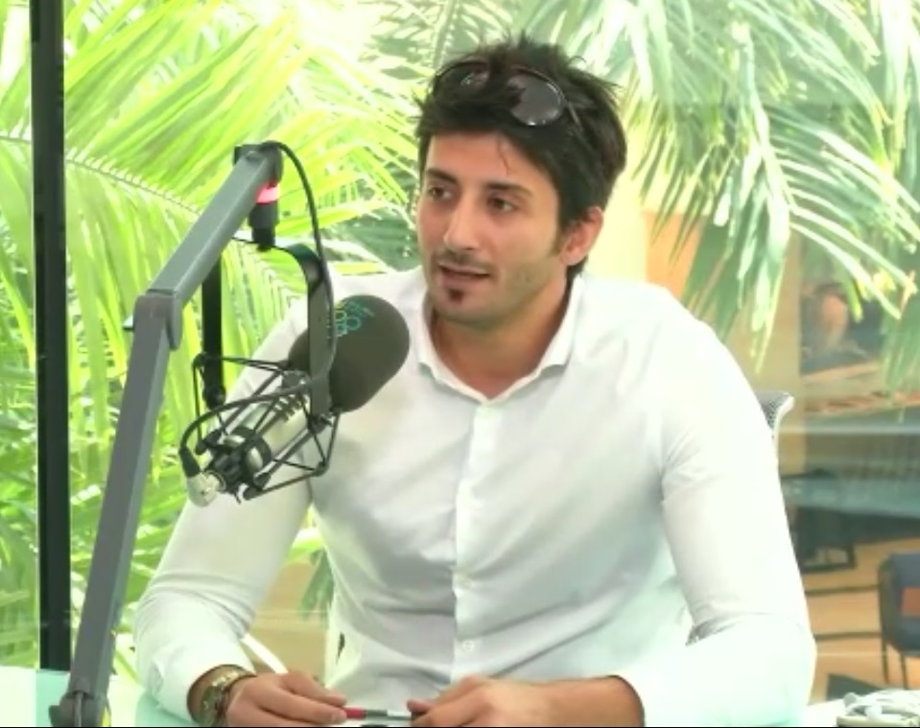
Personal Profile

A customer oriented connector and an influencer with more than 10 years of experience in PR & Marketing management, Business Development, and Team Management: with the ability to understand the ongoing market scenarios and customers’ trends using exceptional marketing communication skills and knowledge, including:
- Strategic planning and strategic leadership
- Decisive: Capable of delivering quick solutions to any business challenges
- Result oriented: Ability to achieve target within given time
Education & Advanced Training
2014 Master of Science in Business Psychology
A degree with the focus on using psychological methods in business, this helps in understanding, predicting, and managing clients’ behaviours. The University of East London, United Kingdom (With Merit)

2011 Master Human Capital Strategist / A Qualified international Business Trainer MHCS
A professional degree in teams’ leadership and management from Human Capital Institute in Washington.

2006 Bachelor of Communications
(Double major) Public Relations & Business Management
Edith Cowan University (Western Australia, Australia) (Distinction honours)

Work Experience

2015 – Current / Marketing & Public Relations Manager – Kuwait College for Science & Technology

- Report to the President of the University.
- Develop and implement creative marketing strategies - with a special emphasis on customer recruitment- from concept to completion, including message development, writing, project management, and client interaction.
- Develop communications campaigns with appropriate media in order to attract inquiries from the market.
- Plan and arrange internal events and exhibitions in the university with all sort of audience including; student clubs graduation ceremonies, ministries, corporate events, and events with embassies and UN bodies.
- Focus heavily on Social Media (Instagram, Facebook, & Snapchat) and constantly view feedback.
- Work with different ministries to arrange variety of tasks including scholarships, government events, visits, as well open days with PR teams from different ministries.
- Write key messages (for print, visual, and social media) and adapt based upon target audience and purpose.
- Initiate and manage production of brochures, newsletters, fact sheets, advertising copy, web site content and other marketing communications materials from concept to completion.
- Work on creative artworks for all channels, use final cut pro X for video production and create shooting scenarios
- Act as the university's ambassador and create successful links between the university and other vendors and/or organizations. (Completed partnership with Arsenal Football Academy London, Dalarna University Sweden, and many other local partners).

2015 – Current Media Marketing Manager Part-time – Marina Media (Radio, TV, Events and Social media units)

Key Achievement: introduced Marina TV and social media channels for the first time to the Kuwaiti market and built events management unit, along with other marketing activities generating with my team more than 250,000KD/ 3Qrs
- Plan and implement social media strategy, monitor trends, and encourage adoption of social media tools
- Identify, develop, and evaluate marketing strategy, based on knowledge of establishment objectives, market characteristics, and cost and markup factors.
- Manage entire product marketing cycle – Planning and applying the use of various sales strategies
- Manage the budget of Marketing unit, including dealing with vendors and purchasing activities
- Initiate and coordinate advertising campaigns and promotional activities
- Control all aspects of production line & select products to be displayed at promotional events and exhibitions
- Manage all media activities including press releases, Marina brand, and present Marina media in all events
2010 – 2014 Sr. Marketing Executive – Gulf University for Science & Technology, Kuwait
Key Achievement: Successfully built a unit and a strong team with new training products tailored to the market needs, with total revenue of $2.2M+ between 2010 - 2014
- Used various marketing strategies and communication skills in order to brand PACE in the training market and attract new clients from Kuwait, KSA, UAE, and Qatar
- Successfully built a reputable and a competitive training/profit center for the university
- Created social media channels and Worked on all updates (website, twitter, Instagram)
- Managed the performance and activities of the Marketing team, including contracted marketing and media service (worked closely with PR & advertising partners in Kuwait on our campaigns)
- Developed and maintained strong and effective relationships with the media in Kuwait (TV and newspapers), this includes representing the university in TV, Radio, or newspaper interview as well as writing press releases in both Arabic and English.

2012 - 2013 Public Relations Assistant Manager MEPI Project - US Embassy, Kuwait (while working at GUST)
- Worked closely with local marketing agencies on meeting marketing objectives and goals
- Built, Performed, and sustained social media community management duties
- Implemented social media strategies by growing the on-line supporter base and traffic
- Produced and published mass communications with email blasts and marketing campaigns
- Achieved project’s objective by recruiting from local community the needed members
- Inducted a successful public relations and marketing plan in the leadership program

2009 - 2010 Corporate Marketing & Communications Executive – Human Soft Group, Kuwait
- Initiated corporate training unit in Kuwait (client relations)
- Managed corporate career counselling and training needs (Private and Government)
- Built a corporate pipeline to assist corporate clients and Government entities and Ministries in Kuwait and GCC generating 170,000KD (3 projects)

2006 - 2009 Recruitment Officer – MIS Australia, Australia
- Identified suitable candidates; matched job seekers with employers and organized interviews for candidate as requested by the client
- Negotiated salary rates and finalize arrangements between client and candidates
- Used Public Relations & Marketing techniques to establish and represent the agency

Consultation Projects:

ALKARMA Pharmaceutical International Company, Kuwait - Marketing Consultant (Jan 2016 – current)

- Work as an acting marketing manager reporting to CEO
- Create social media unit
- Restructured the company’s identity, website, logo, and Introduced individual sales unit
- Write key messages (for print, visual, and social media) and adapt based upon target audience and purpose.
- Initiate and manage production of brochures, newsletters, fact sheets, advertising copy, web site content and other marketing communications materials from concept to completion.
- Direct all marketing, corporate image and social activities
- Work along with CEO on department budget planning
- Work as an effective link between media agency and marketing team

BoxinUS, United States of America – Marketing and social media consultant (March 2016 – current)

- Report to Marketing & Customer Service Director in NYC
- Introduced BoxinUS services in the Kuwaiti market
- Supervise produced artworks produced on the website and social media stations
- Changed website content (Arabic/English)
- Supervise social media activities and advise on needed actions
- Work with local agencies and social media celebrities to advertise services.

Malaga Club de Futbal, Spain – Marketing consultant for Kuwait (Feb 2016)

- Report to Marketing Director in Spain
- Work on finding sponsors for the club in La Liga from major banks in Kuwait
- Introduce Malaga Academy Kuwait
- Allocate special gift items for the Kuwaiti youth in local exhibitions and occasions to increase clubs popularity

Training and Professional Certifications

2015 Apple - Final Cut Pro X, Istanbul Academy of Production, Turkey.
2014 Future Leaders, London City College (London, UK)
2013 Problem Solving and Decision Making Strategies, GUST (Kuwait)
2013 Project Management Professional (PMP) (Kuwait)
2012 Marketing Strategic Planning, Oxford University (Oxford, UK)
2012 Communications Management, Dale Carnegie Training (Kuwait)
2011 Master Human Capital Strategist, Human Capital Institute (USA)
2011 Leadership & Management, Loughborough University (UK)
2008 Public Relations Crisis Management - ECU (Western Australia)

