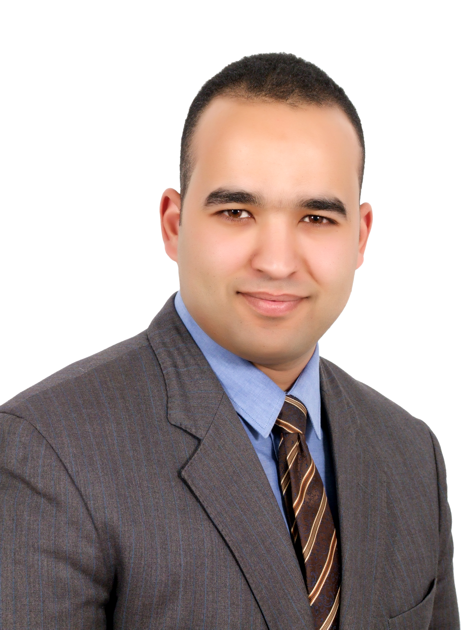
Elsayed Ali AboFarha, PHD
6th October –third province – bloc 6, building no, 1176
Cairo, Egypt
Mobile: 002 01123227000
E-Mail:
abofarha2020@eps.bsu.edu.eg
abofarha2020@yahoo.com

Personal Data:
Marital Status : married
Age : 29
Date of birth : 1 sep, 1986
Nationality : Egyptian
Military Status : completed
Current position:
- Assistant professor of political science at faculty of economic studies and political science – Beni Suef University from March 2013.
External studies:
- Fellow of Massachusetts Amherst University 2015 (Donahue Research Institute "American Political Thought").
- Take lectures about international politics at universities of Connecticut, Virginia, Shippensburg, and Massachusetts Amherst.
Education:
- PHD degree with excellent on political science from faculty of economics and political science, Cairo university on September 2015, and the thesis about “judiciary’s political role in democratization: comparative study”.
- Master degree of political science – faculty of economics and political science, Cairo univ, 2011, the thesis about “Military’s political role in democratization in Mauritania”.
- Bachelor of political science – faculty of economics and political science, Cairo univ, (2007)
- Grade: v.good with honors.
Teaching courses:
- Teaching many courses about introduction of political science, political thought, public policy making.
Participation with papers at international conferences:
- Qatar on 27th September 2013 (conference of the Arab center of policy studies and researches)
- Lebanon on 18th March 2013 (conference of the Arab council of social sciences)
- Turkey, Istanbul University on 2ed May 2013 (the third Turkish Arab annual conference of social
Sciences)
- Cairo, American university in Cairo “AUC” 5-7 December 2015, (the forth global conference of public policies & management “AMEPPA2015”).

Work Experience:
- Freelance writer at a number of Reginal Arab periodicals and scientific journals on the Arab and African affairs.
- Public Policy Researcher at General Authority for Investment in Cairo (September 2009 – February 2013).
- Policy making Researcher at the Arab Center for humanitarian Studies in Cairo, the
(July 2009 - October 2009).
- Public policy Researcher at the Arab Center for parliamentary Studies and parliamentary house expertise in Cairo under the chairmanship of Prof. Dr. Ali El Sawy (March 2009 - July 2009).
- Research Assistant at the Office of Major General Dr. / Mahmoud Khalil Al Nasser Higher Military Academy (March 2008 - February 2009).
- Public policy Researcher at a research project of the National Council for Woman under the supervision of Dr. / Nevine Abdel-Moneim Massad entitled (the impact of the electoral map on the political participation of women in Egypt) (the month of July-December 2007).

Some of my Books and Publications:
- A book published in Arabic entitled The implications of qualitative transformation in the terrorist phenomenon on the Arab national state, Future Studies Unit, Center for Strategic Studies, Bibliotheca Alexandrina, Egypt, 2016, available at the following link:
https://www.bibalex.org/Attachments/Publications/Files/2017091212265064087_Awraq25final1293.pdf
- Book entitled "The shifts in the political map of Mauritania: its dimensions - its edges - Scenarios of future" first edition 2010, and it can be found via the link to the Center as follows:
- https://searchworks.stanford.edu/view/10230948
- http://findit.library.gwu.edu/item/13490289
- Book chapter about democratization and military in Mauritania, published in book entitled: “military and democratization in Africa” by the forum of Arab and international relations in Qatar.
http://fairforum.org/book/%D8%A7%D9%84%D8%AC%D9%8A%D9%88%D8%B4-%D9%88%D8%A7%D9%84%D8%AA%D8%AD%D9%88%D9%91%D9%84-%D8%A7%D9%84%D8%AF%D9%8A%D9%85%D9%82%D8%B1%D8%A7%D8%B7%D9%8A-%D9%81%D9%8A
- A research entitled "external actor in Somalia: its nature and its motives and its borders," the seventh report of the pilot of the Journal of the statement in 2009, and it can be found via the following email link:
http://www.aljazeera.net/NR/exeres/9B27D103-1F5A-45A6-987D-EC7BFFA00877.htm
- Report entitled "The general election in sub-Saharan Africa: a new step towards democratization of the armed conflict or a" strategic report 2011 issued by the African Institute of African Research and Studies, Cairo University with funding from the Ministry of Foreign Affairs.
- A study entitled "the situation of Muslims in Nigeria and the problem of state-building: a temporary exclusion or permanent defect," in "Readings African" the January 2012, issued by the Islamic Community in London - and Riyadh.
- A study entitled "The future of the African country between the influence of the military and feasibility of democracy," in "Readings African" the July 2012, issued by the Islamic Community in London - and Riyadh.
- These are links of A sample of my research:
- https://searchworks.stanford.edu/view/10230948
- http://findit.library.gwu.edu/item/13490289
- http://fairforum.org/book/%D8%A7%D9%84%D8%AC%D9%8A%D9%88%D8%B4-%D9%88%D8%A7%D9%84%D8%AA%D8%AD%D9%88%D9%91%D9%84-%D8%A7%D9%84%D8%AF%D9%8A%D9%85%D9%82%D8%B1%D8%A7%D8%B7%D9%8A-%D9%81%D9%8A-%D8%A5%D9%81%D8%B1%D9%8A%D9%82%D9%8A/
- http://www.qiraatafrican.com/_pdf/13.pdf
- http://www.qiraatafrican.com/_pdf/n16.pdf
- http://www.qiraatafrican.com/_pdf/n17(7).pdf
- http://www.qiraatafrican.com/view/?q=1785
- http://www.qiraatafrican.com/view/?q=1839
- http://www.egyptindependent.com/node/1977041

